<https://www.learningjournal.guru/article/kafka/installing-kafka-on-windows/>

Steps to install Kafka in windows environments

1. Install java jdk and open probertites of pc and add the new path on it with name of it
2. Visit <https://kafka.apache.org/> and download the kafka [**kafka_2.12-2.4.0.tgz**](https://downloads.apache.org/kafka/2.4.0/kafka_2.12-2.4.0.tgz)
3. Then uncompressed this and put it in c:windows or any place you wanted
4. Then you configure it
5. Create folder which name zookeeper and keep its path
6. Open zookeeper.proberites and make the dirlocation point to this path which is above
7. Then configure the server.proberites change kafka log dir
8. After finished we will add this path C:\Windows\kafka_2.12-2.4.0\bin\windows in path of variable windows machine

**Start**

1. Open cmd and type

zookeeper-server-start.bat C:\Windows\kafka_2.12-2.4.0\config\zookeeper.properties

kafka-server-start.bat C:\Windows\kafka_2.12-2.4.0\config\server.properties

**if you want to know the brokers ids that running on your machine you will type this**

**commands**

zookeeper-shell.bat localhost:2181 ls /brokers/ids

**if you want to create topic you will type this command**

kafka-topics.bat --create --zookeeper localhost:2181 --replication-factor 1 --partitions 1 --topic Zeina

btes23022020

**if you want to make a producer you will type**

kafka-console-producer.bat --broker-list localhost:9092 --topic zeinabtest23022020

**if you want to make consumer you will type this**

kafka-console-consumer.bat --bootstrap-server localhost:9092 --topic zeinabtest23022020 --from-beginning

**which nuget you can use in c# .net that belongs to kafka ?**

actullly you have more but the most famous is “kafka-net” ,and kafka confluent

**how to know details about partitions**

kafka-topics --describe --zookeeper localhost:2181 --topic topic_name

**if you want list all consumer group you have ?**

**kafka-consumer-groups.bat -bootstrap-server localhost:9092 -list**

keep in mind

when I try to produce 1000000 it success but after a long time but when consumed it crashed and give no broker has commit the solution for this that delete logs so every thing is deleted

Keep in mind

**When I try to delete specific topic the Kafka has stopped suddenly**

**BECAUSE IT MARKED AS “MARKED AS DELETED ”**

**WHAT IS THE DIFFRENCE BETWEEN THAT ?**

# [When/how does a topic “marked for deletion” get finally removed?](https://stackoverflow.com/questions/23976670/when-how-does-a-topic-marked-for-deletion-get-finally-removed)

<https://stackoverflow.com/questions/23976670/when-how-does-a-topic-marked-for-deletion-get-finally-removed>

java.nio.file.AccessDeniedException: kafka logs

# [AccessDeniedException when deleting a topic on Windows Kafka](https://stackoverflow.com/questions/50755827/accessdeniedexception-when-deleting-a-topic-on-windows-kafka)

<https://stackoverflow.com/questions/50755827/accessdeniedexception-when-deleting-a-topic-on-windows-kafka>

for now I reached to that the delete of topic crach the kafka

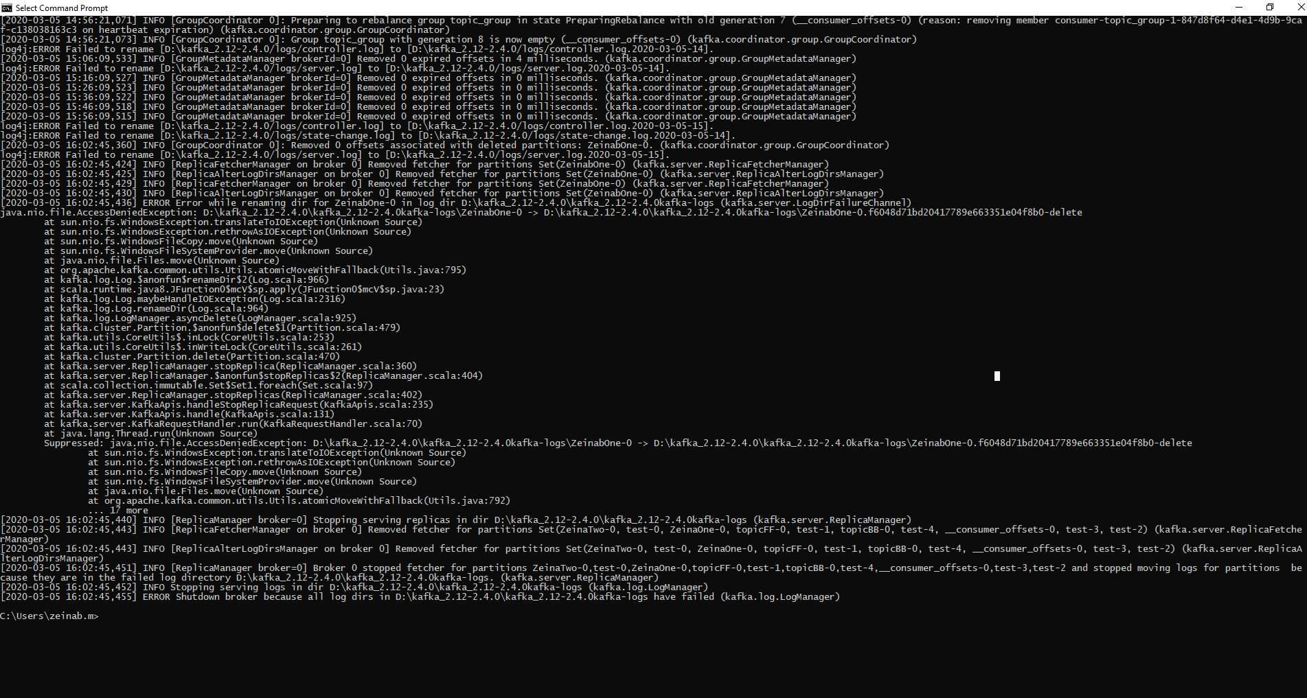

**مع الاسف كل الاراء الموجوده حاليا بتقول عشان تحل المشكله دى أمسح اللوج ورستر الكفكا هتقوم   
بس انا كزينب مش راضية عن الحل ده وبعت ع الجيت هيب ايشو ولسه بسيرش   
ومع الاسف أيضا كثيرا من الايشوز مرصوده ع الموقع الرسمى للجيرا للكفكا بتتناقش فى هذه المشكله****actually and unfortunately this issue is repeated by some of users and reported in**

**Official Jira for Kafka and there is no professional solution for that till now**

<https://stackoverflow.com/questions/56032833/kafka-server-is-not-getting-started-showing-error>  
<https://github.com/confluentinc/kafka-streams-examples/issues/323>

**Note that the official website for Kafka tell us this already issue**   
<https://issues.apache.org/jira/browse/KAFKA-7020>

<https://issues.apache.org/jira/browse/KAFKA-8811>

keep in mind that

when I make consumer group and consume topic it doesn’t get all old messages

but when I run individual consumer it get old also

from the performance

individual consumer is faster than consumer group

individual consumer

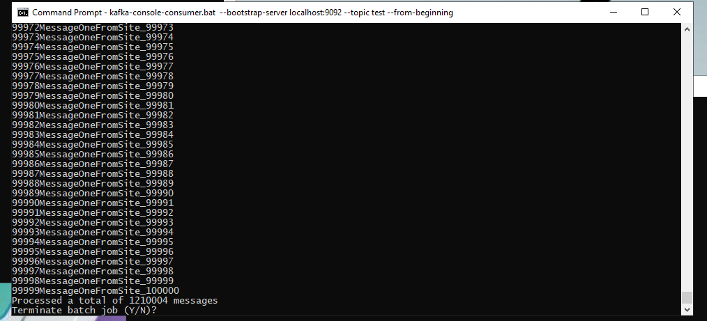

Consumer group